 | Computer Organization and Assembly Language (EL-2003)
Semester: Fall 2025
Section: BCS-3J / BCS-3K
Course Instructor: Seema Hashwani
LAB # 11

String Handling Instructions, Two dimensional array

Lab Objectives:
By the end of this lab, students will be able to:
- Work with String Primitive Instructions.
- Selected String Procedures.
- Two-Dimensional Arrays.
- Searching and Sorting Integer Arrays.

String Primitive Instructions

String instructions in assembly are special instructions used to process sequences of data (strings, arrays, memory blocks). They automatically work with memory pointed by ESI (source index) and EDI (destination index) registers, and often with ECX (counter) for repetition. String primitives execute efficiently because they automatically repeat and increment array indexes.
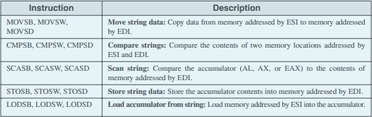
These instructions are:

Direction Flag:
String primitive instructions increment or decrement ESI and EDI based on the state of the Direction flag. The Direction flag can be explicitly modified using the CLD and STD instructions:
CLD ; clear Direction flag (forward direction)
STD ; set Direction flag (reverse direction)
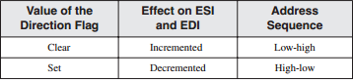

Repeat Prefix:
By itself, a string primitive instruction processes only a single memory value or pair of values. If you add a repeat prefix, the instruction repeats, using ECX as a counter. The repeat prefix permits you to process an entire array using a single instruction. The following repeat prefixes are used:

1. MOVSB, MOVSW, and MOVSD:

The MOVSB, MOVSW, and MOVSD instructions copy data from the memory location pointed by ESI to the memory location pointed to by EDI. The two registers are either incremented or decremented automatically (based on the value of the Direction flag).

We can use a Repeat Prefix with MOVSB, MOVSW, and MOVSD. The Direction flag determines whether ESI and EDI will be Incremented or Decremented.

In the example below, REP MOVSB string instruction copies all characters from string1 into string2. After copying, it displays the contents of string2, which now shows the same text as string1.
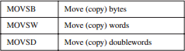
INCLUDE Irvine32.inc

.data
string1 BYTE "this is first string",0
string2 BYTE 50 DUP(?) ; reserve space for copied string

.code
main PROC
cld ; clear direction flag
mov esi, OFFSET string1 ; ESI points to source
mov edi, OFFSET string2 ; EDI points to destination
mov ecx, SIZEOF string1 ; number of bytes to copy
rep movsb ; copy string1 → string2

mov edx, OFFSET string2 ; display copied string
call WriteString

exit
main ENDP
END main

2. CMPSB, CMPSW, and CMPSD:

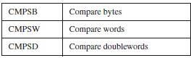
The CMPSB, CMPSW, and CMPSD instructions each compare a memory operand pointed to by ESI to a memory operand pointed to by EDI: You can use a repeat prefix with CMPSB, CMPSW, and CMPSD. The Direction flag determines the incrementing or decrementing of ESI and EDI.

.data
greater BYTE "source > target",0
lessOrEqual BYTE "source <= target",0
source BYTE "abcd",0
target BYTE "abc",0

.code
main PROC
cld ; Clear direction flag (forward compare)
mov esi, OFFSET source ; ESI points to source string
mov edi, OFFSET target ; EDI points to target string
mov ecx, LENGTHOF source ; Number of bytes to compare (length of source)

repe cmpsb ; Compare byte-by-byte while equal
; Stops if mismatch or ECX=0

ja L1 ; If source > target
mov edx, OFFSET lessOrEqual ; Else source <= target
call WriteString
jmp endd
L1:
mov edx, OFFSET greater
call WriteString

endd:
exit
main ENDP
END main

3. SCASB, SCASW, and SCASD:

The SCASB, SCASW, and SCASD instructions compare a value in AL/AX/EAX to a byte, word, or double word, respectively, addressed by EDI. The instructions are useful when looking for a single value in a string or array. Combined with the REPE (or REPZ) prefix, the string or array is scanned while ECX > 0 and the value in AL/ AX/ EAX match each subsequent value in memory. The REPNE prefix scans until either AL/AX/EAX matches a value in memory or ECX = 0.

Example: Scan for a Matching Character
In the following example we search the string alpha, looking for the letter F. If the letter is found, EDI points one position beyond the matching character. If the letter is not found, JNZ exits:

.data
alpha BYTE "ABCDEFGH",0
.code
mov edi,OFFSET alpha | ; EDI points to the string
mov al,'F' | ; search for the letter F
mov ecx,LENGTHOF alpha | ; set the search count
cld | ; direction = forward
repne scasb | ; repeat while not equal
jnz quit | ; quit if letter not found
dec edi | ; found: back up EDI

JNZ was added after the loop to test for the possibility that loop stopped because ECX = 0 that the character in AL was not found.

STOSB, STOSW, and STOSD:

The STOSB, STOSW, and STOSD instructions store the contents of AL/AX/EAX, respectively, in memory at the offset pointed to by EDI. EDI is incremented or decremented based on the state of the Direction flag. When used with the REP prefix, these instructions are useful for filling all elements of a string or array with a single value. For example, the following code initializes each byte in string1 to 0FFh:

Example:
.data
Count = 100
string1 BYTE Count DUP(?)
.code
mov al,0FFh | ; value to be stored
mov edi,OFFSET string1 | ; EDI points to target
mov ecx,Count | ; character count
cld | ; direction = forward
rep stosb | ; fill with contents of AL

LODSB, LODSW and LODSD:

The LODSB, LODSW, and LODSD instructions load a byte or word from memory at ESI into AL/AX/EAX, respectively. ESI is incremented or decremented based on the state of the Direction flag. The REP prefix is rarely used with LODS because each new value loaded into the accumulator overwrites its previous contents. Instead, LODS is used to load a single value. In the next example, LODSB substitutes for the following two instructions (assuming the Direction flag is clear):

mov al,[esi] ; move byte into AL inc esi ; point to next byte

Array Multiplication:
The following program multiplies each element of a doubleword array by a constant value. LODSD and STOSD work together:
TITLE Multiply an Array (Mult.asm)
; This program multiplies each element of an array
; of 32-bit integers by a constant value.

INCLUDE Irvine32.inc
.data
array DWORD 1,2,3,4,5,6,7,8,9,10 | ; test data
multiplier DWORD 10 | ; test data
.code
main PROC
cld | ; direction = forward
mov esi,OFFSET array | ; source index
mov edi,esi | ; destination index
mov ecx,LENGTHOF array | ; loop counter
L1:
Lodsd | ; load [ESI] into EAX
mul multiplier | ; multiply by a value
Stosd | ; store EAX into [EDI]
loop L1
Exit
main ENDP
END main

String Procedures

STR_COMPARE
It compares the strings in forward order, starting at the first byte. The comparison is case sensitive because ASCII codes are different for uppercase and lowercase letters. The procedure does not return a value, but the Carry and Zero flags can be interpreted as shown in Table
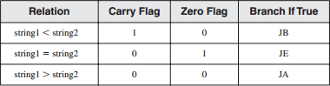

Syntax: INVOKE Str_compare, ADDR string1, ADDR string2
Example:
INCLUDE Irvine32.inc
.data
string1 BYTE 'abcd' ,0 string2 BYTE 'abc',0
.code main PROC
Str_compare PROTO,
INVOKE Str_compare, ADDR string1, ADDR string2 call dumpRegs

exit
main ENDP END main

STR_LENGTH
The Str_length procedure returns the length of a string in the EAX register. When you call it, pass the
string’s offset.
Syntax: INVOKE Str_length, ADDR myString
Example:
INCLUDE Irvine32.inc
.data
string1 BYTE 'Hello World' ,0

.code main PROC mov eax,0
Str_length PROTO,
INVOKE Str_length, ADDR string1 call dumpRegs
Exit
main ENDP
END main

STR_CPY
The Str_copy procedure copies a null-terminated string from a source location to a target location. Before calling this procedure, you must make sure the target operand is large enough to hold the copied string.

Syntax: INVOKE Str_copy, ADDR source, ADDR target
Example:
INCLUDE Irvine32.inc
.data
string_1 BYTE "COAL",0 string_2 BYTE " ", 0

.code main PROC
INVOKE Str_copy,ADDR string_1,ADDR string_2 mov edx,OFFSET string_2
call WriteString

exit
main ENDP
END main

STR_TRIM PROCEDURE
The Str_trim procedure removes all occurrences of a selected trailing character from a null-terminated string.
Syntax: INVOKE Str_trim, ADDR string, char_to_trim
Example:
INCLUDE Irvine32.inc
.data
string_1 BYTE "Hellooo",0
.code
main PROC
INVOKE Str_trim,ADDR string_1,'o' mov edx,OFFSET string_1
call WriteString

exit
main ENDP
END main

STR_UCASE PROCEDURE
The Str_ucase procedure converts a string to all uppercase characters. It returns no value. When you call it, pass the offset of a string.

Syntax: INVOKE Str_ucase, ADDR myString
Example:
INCLUDE Irvine32.inc
.data
string_1 BYTE "Coal",0
.code main PROC

INVOKE Str_ucase,ADDR string_1 mov edx,OFFSET string_1
call WriteString
exit
main ENDP END main

Two Dimensional Arrays

From an assembly language programmer’s perspective, a two-dimensional array is a high-level abstraction of a one-dimensional array. High-level languages select one of two methods of arranging the rows and columns in memory: row-major order and column-major order
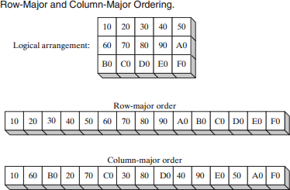

If we implement a two-dimensional array in assembly language, you can choose either ordering method. The x86 instruction set includes two operand types, base-index and base-index-displacement, both suited to array applications.

Base-Index Operands
A base-index operand adds the values of two registers (called base and index), producing an off-set address:
[base+ index]
The square brackets are required. In 32-bit mode, any 32-bit general-purpose registers may be used as base and index registers.
Example:

data
array WORD 1000h,2000h,3000h
.code
mov ebx,OFFSET array mov esi,2
mov ax,[ebx+esi] ; AX = 2000h

Two-Dimensional Array:
When accessing a two-dimensional array in row-major order, the row offset is held in the base register and the column offset is in the index register. The following table, for example, has three rows and five columns:

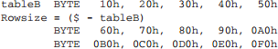
Suppose we want to access particular number from an array.
Assuming that the coordinates are zero based, the entry at row 1, column 2 contains 80h. We set EBX to the table’s offset, add (Rowsize * row_index) to calculate the row offset, and set ESI to the column index:
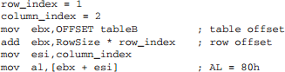
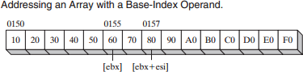

by using Scale Factors
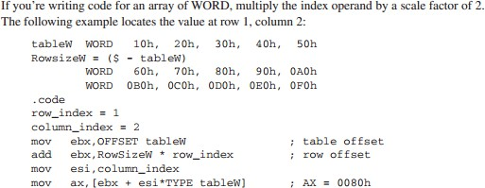

Base-Index-Displacement Operands:
A base-index-displacement operand combines a displacement, a base register, an index register, and an optional scale factor to produce an effective address. Here are the formats:
[base+ index+ displacement] Displacement [base+ index]
Displacement can be the name of a variable or a constant expression. In 32-bit mode, any general- purpose 32-bit registers may be used for the base and index.

Searching and Sorting Integer Arrays

Bubble Sort
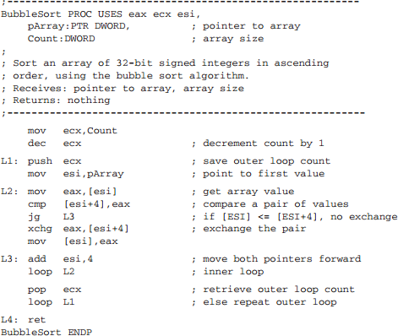
A bubble sort compares pairs of array values, beginning in positions 0 and 1. If the compared values are in reverse order, they are exchanged.

LAB TASKS

Task # 01:

Task # 02:

Task # 03:

